https://absolute-sharepoint.com/

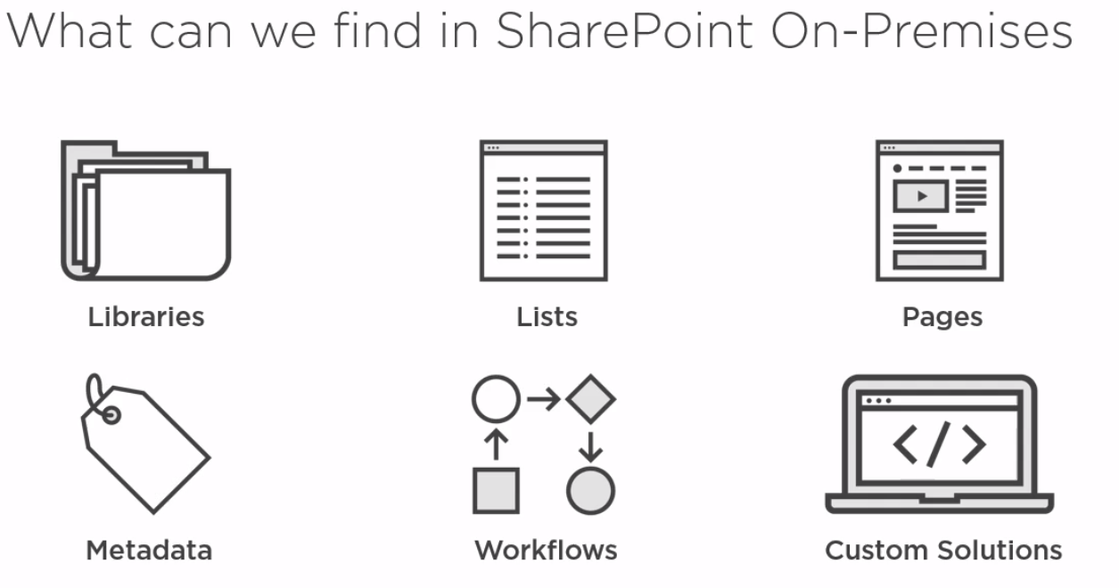

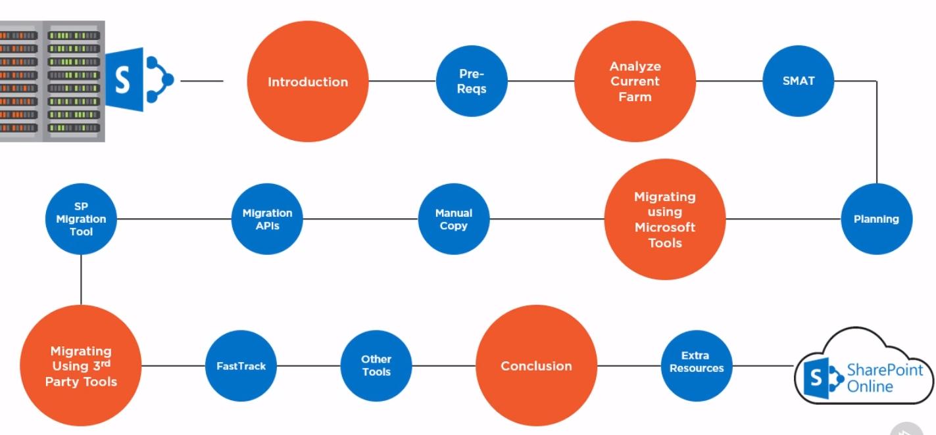

Analyzing your current SharePoint Farm

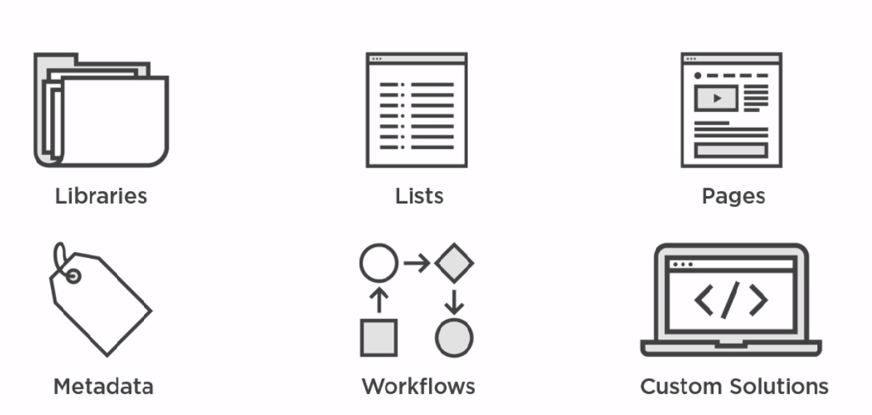

Libraries

Document Version History?

Check In and Check Out?

Lists

Completed columns? Lookup People Calculated

Large Lists? Over 5000 items

Pages

Page Content, Web Parts, Page Layouts?

Metadata

Managed Metadata at the Farm Level?

Managed Metadata at the List Level?

Workflows

Custom Code

Farm Solutions, Apps/Add-ins, Sandbox Solutions

Differences between SharePoint On-Premises and Office 365

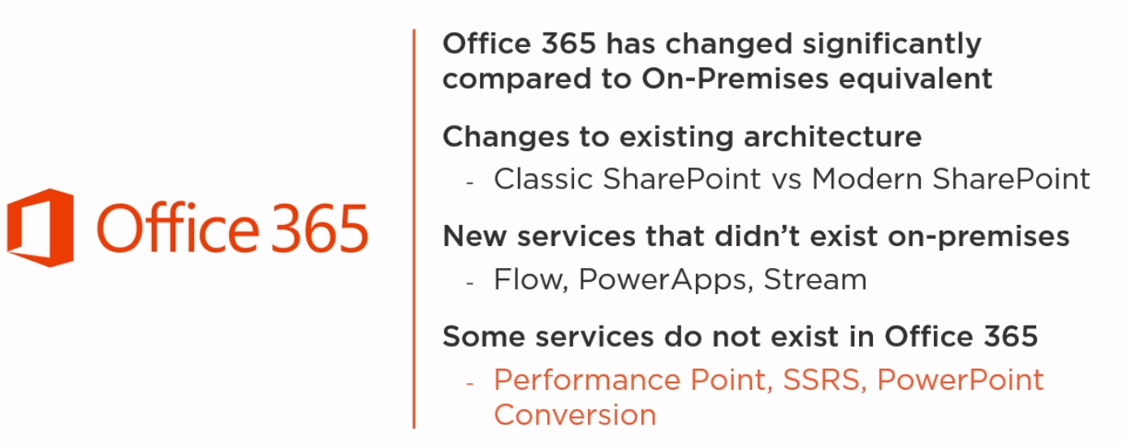

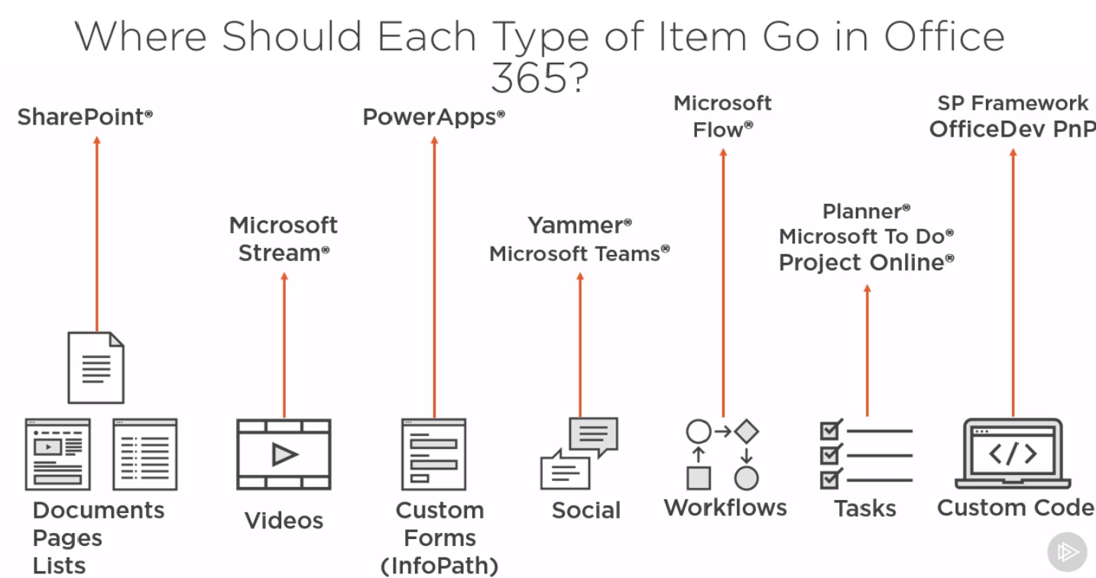

SharePoint Migration Assessment Tool

This Tool only shows you features that are not incompatible for the cloud or SharePoint Online Office 365.

Download the following tool on one of the server on your SharePoint Farm

<https://www.microsoft.com/en-us/download/details.aspx?id=53598>

You need to have the following admin access:

1. Local Administrator
2. Farm Administrator
3. Full Control Access to All Service and Web Applications

Two executables

SMAT2010.exe for SharePoint 2010 environments

SMAT2013.exe for SharePoint 2013 environments

Using PowerShell to Analyze your Current SharePoint Farm

PowerShell can get very detailed information from your SharePoint Farm

Get the Farm Information and export the information to csv file

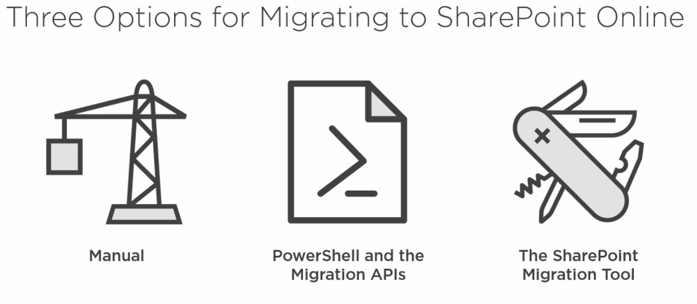

Manual Content Migration

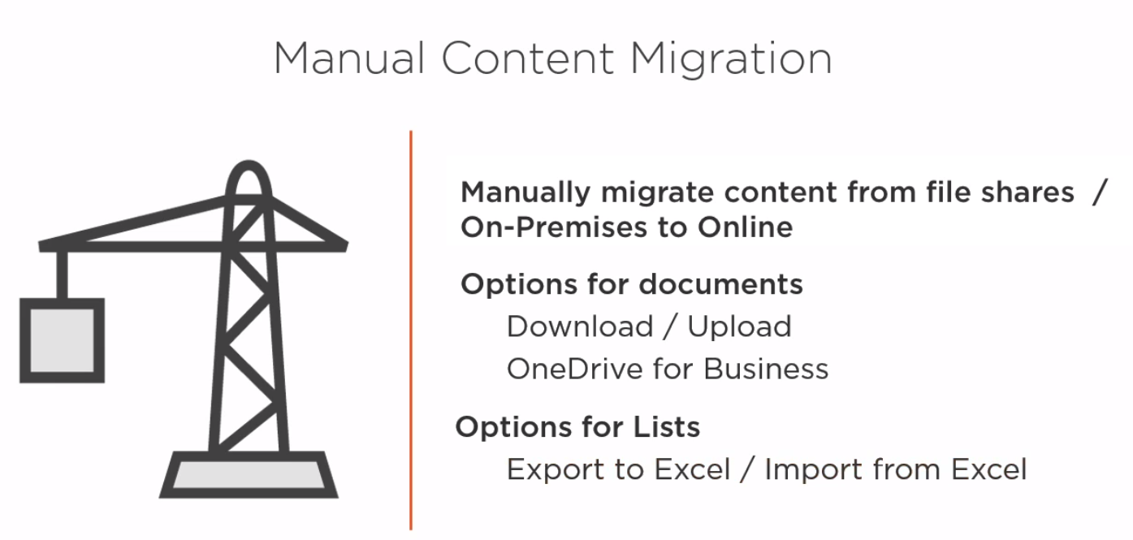

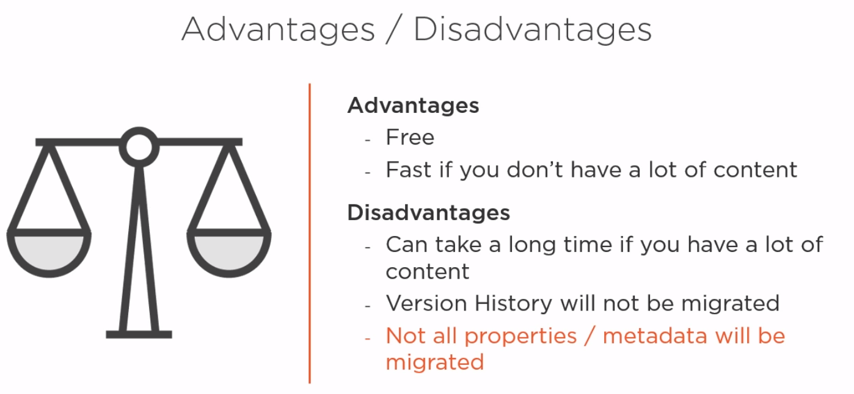

Migrating to SharePoint Online Using PowerShell

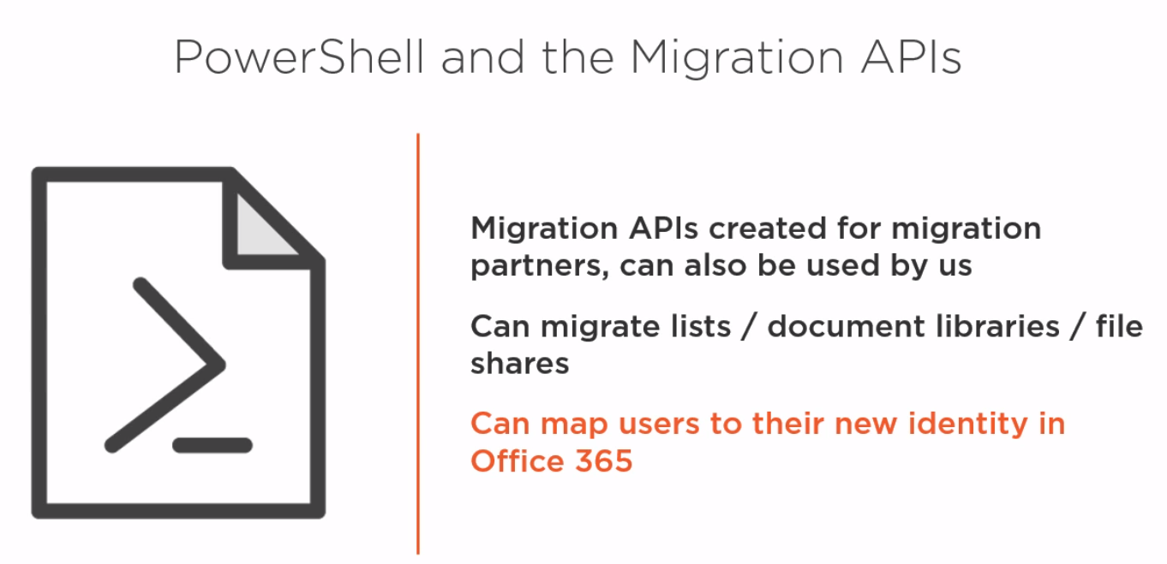

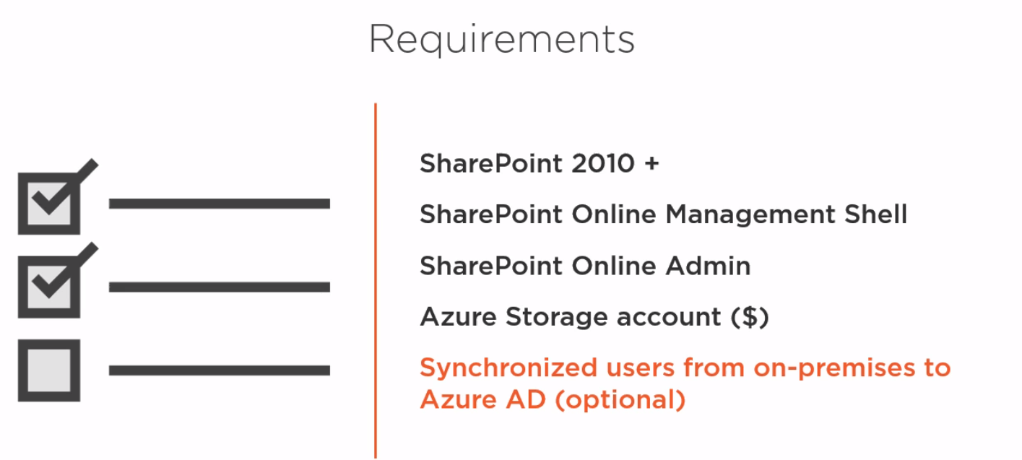

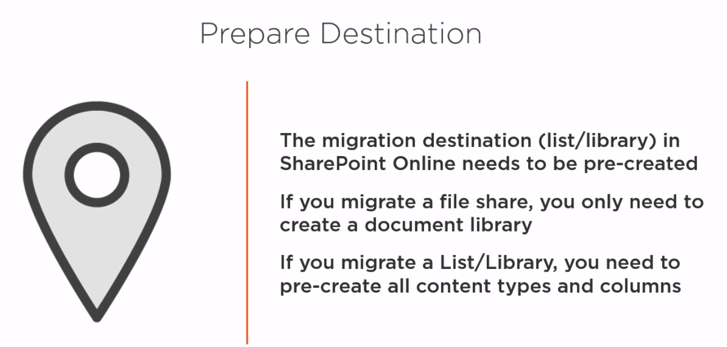

File Shares

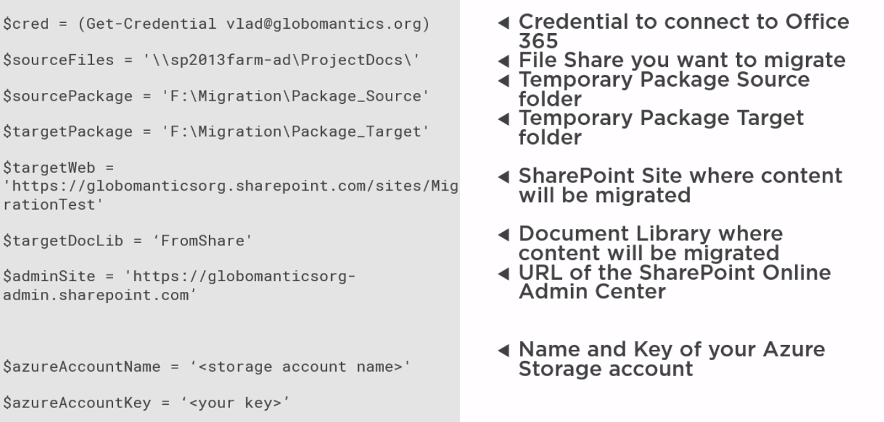

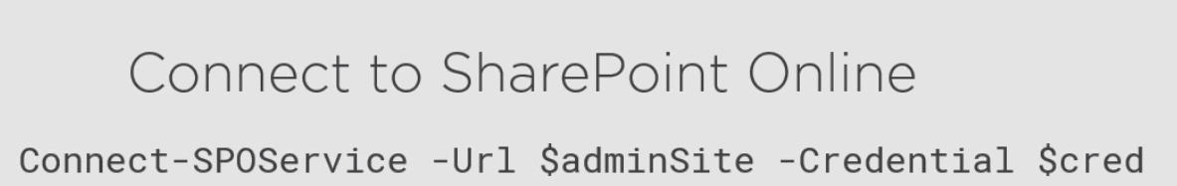

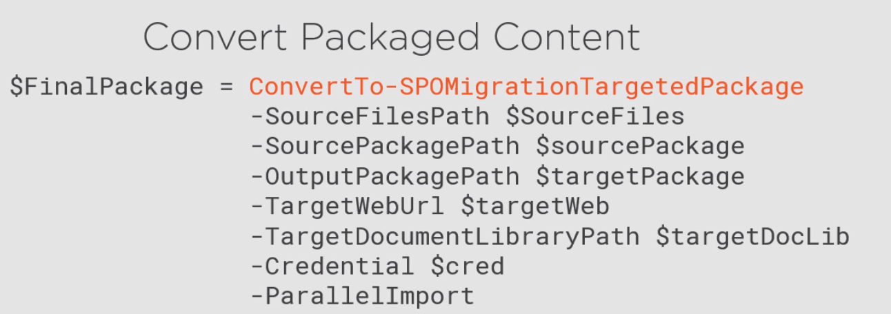

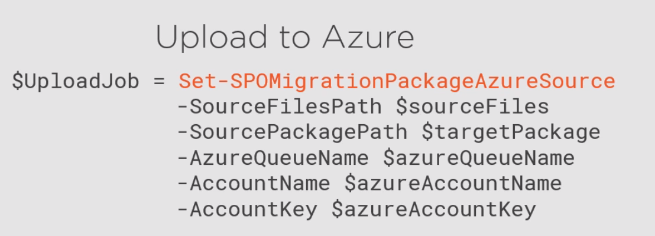

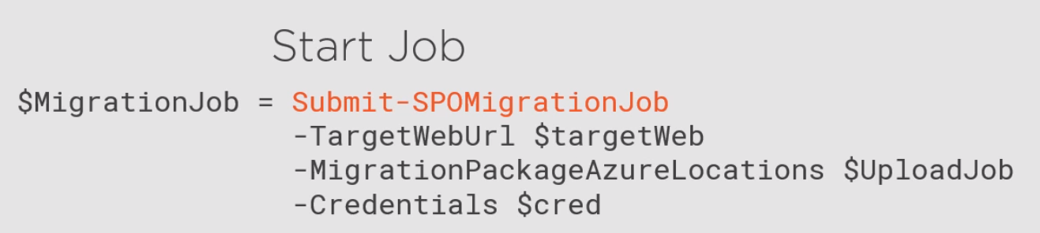

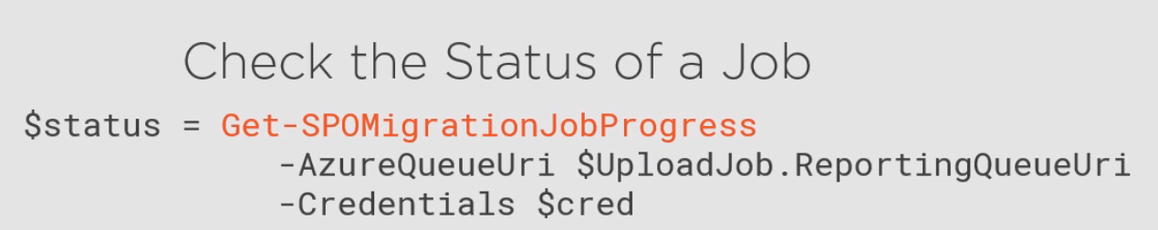

Document Libraries

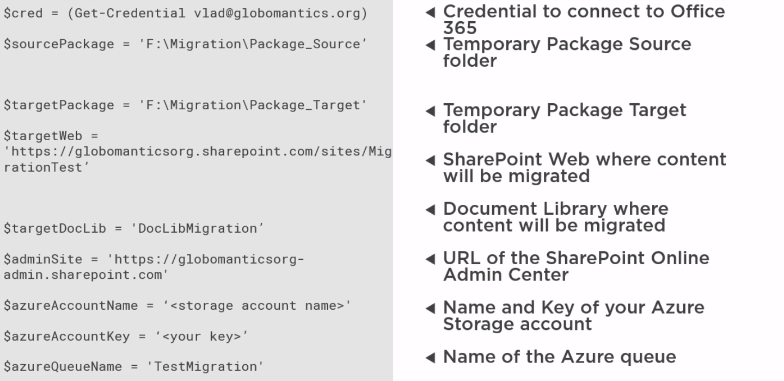



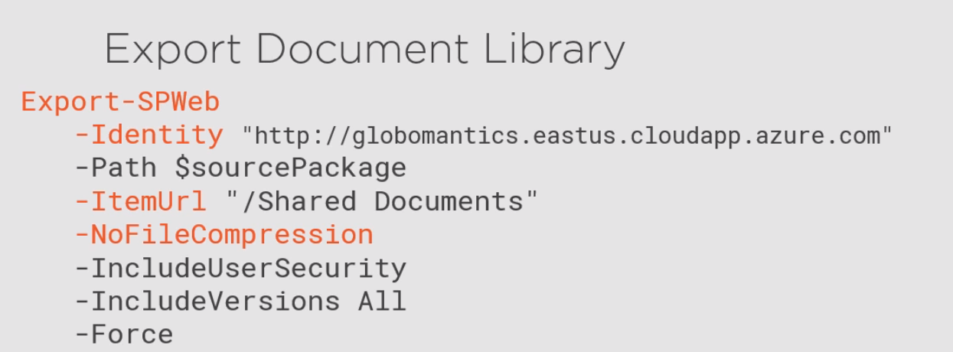

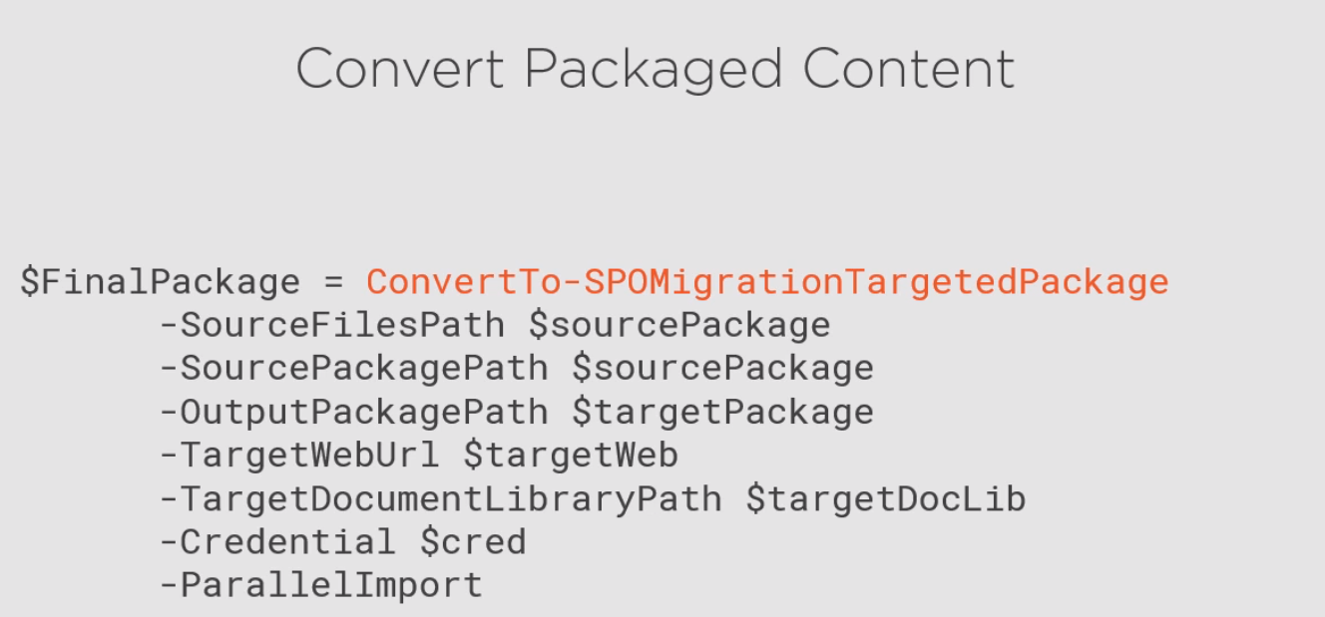

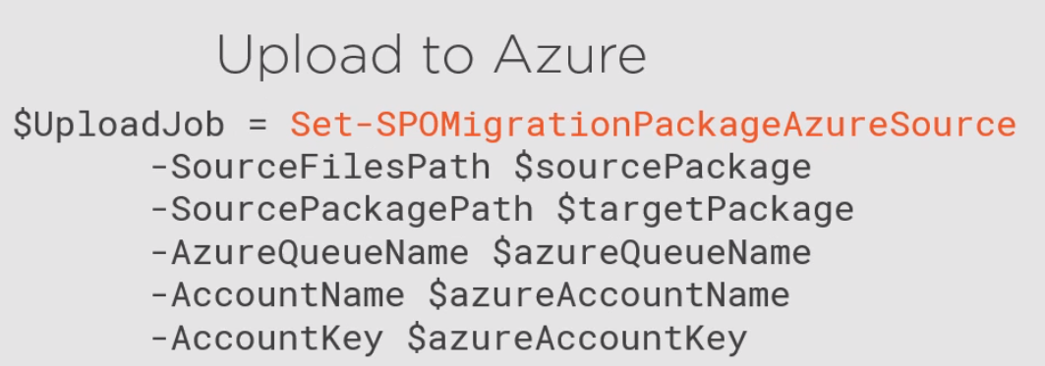



SharePoint Lists

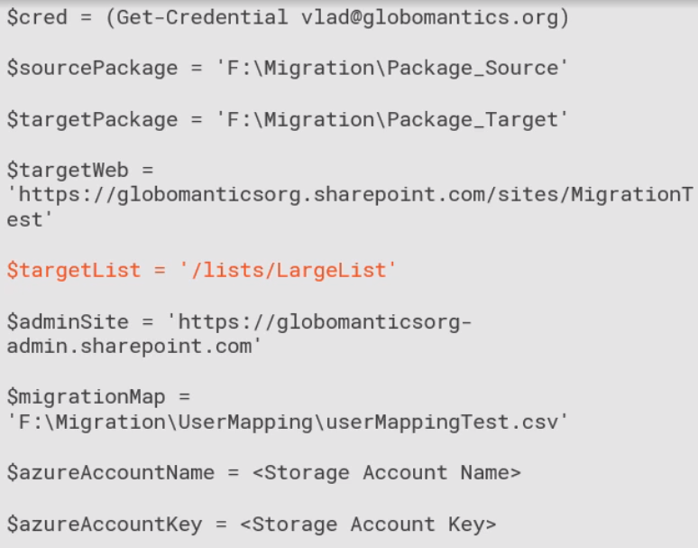



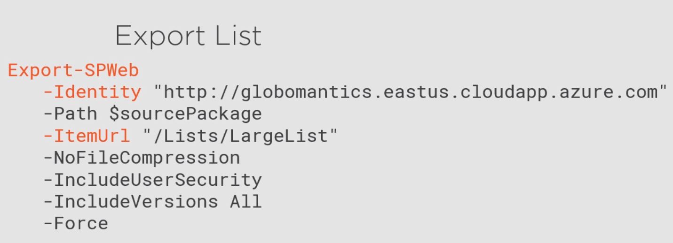

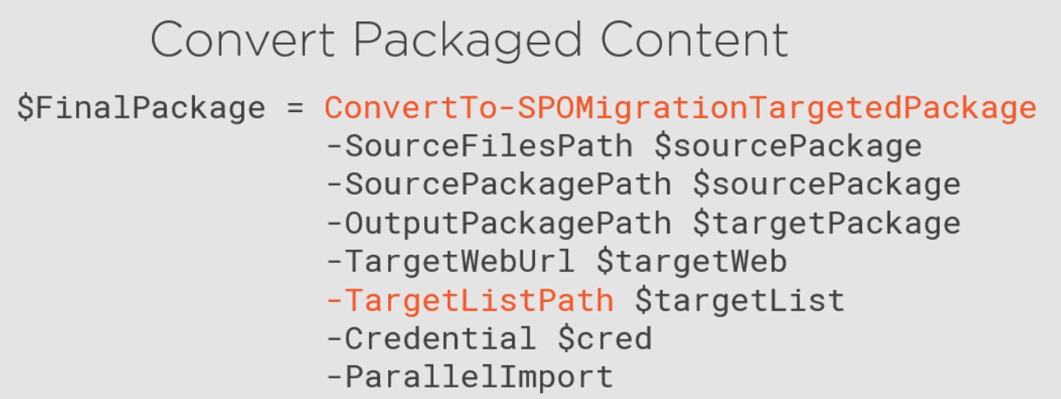

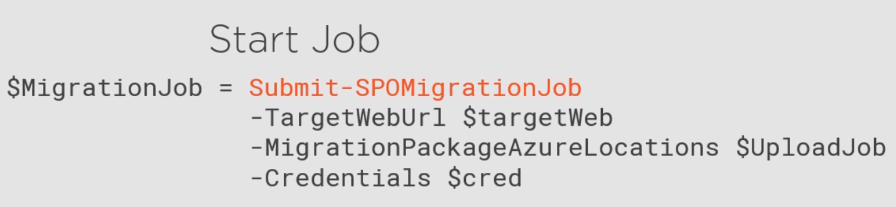



SharePoint Migration Tool

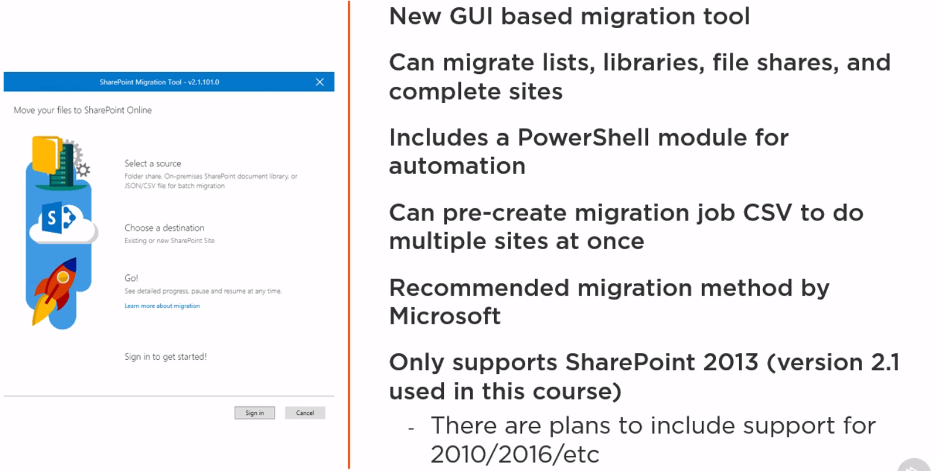

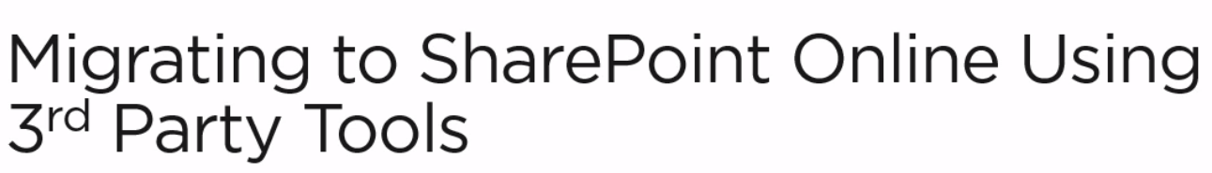

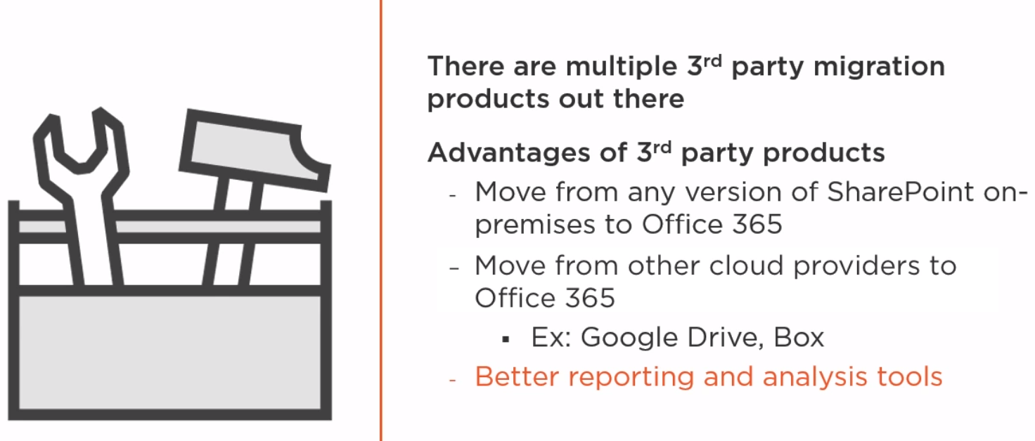

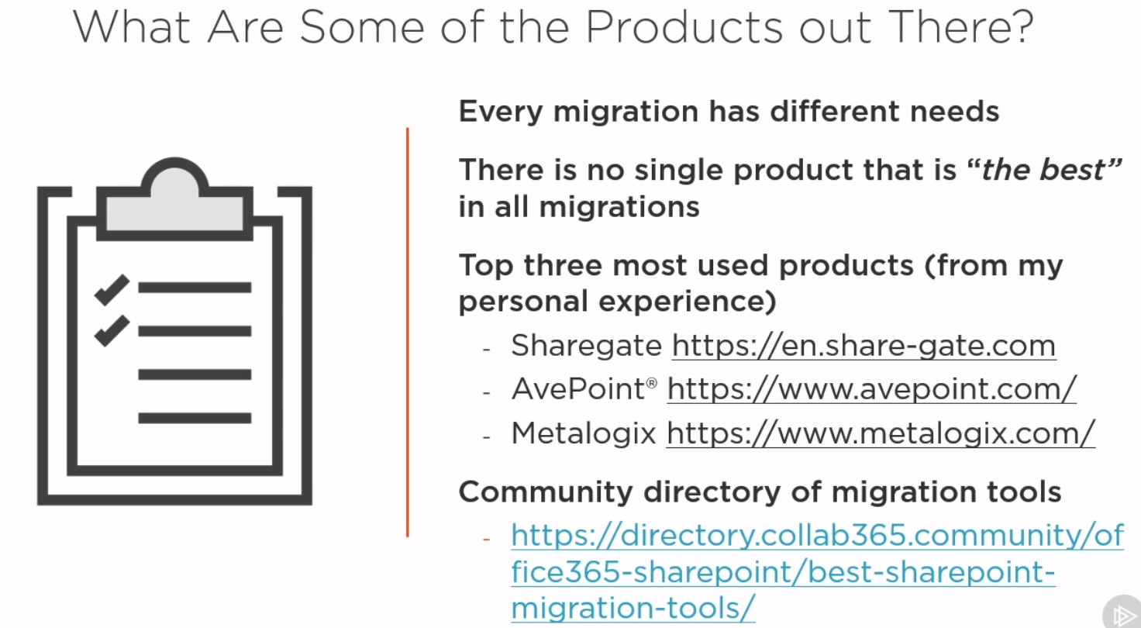

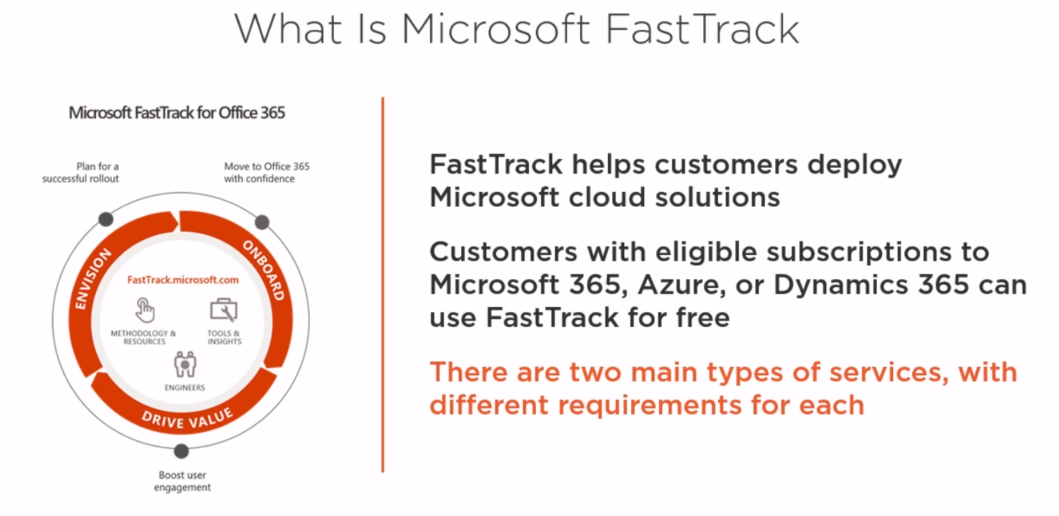

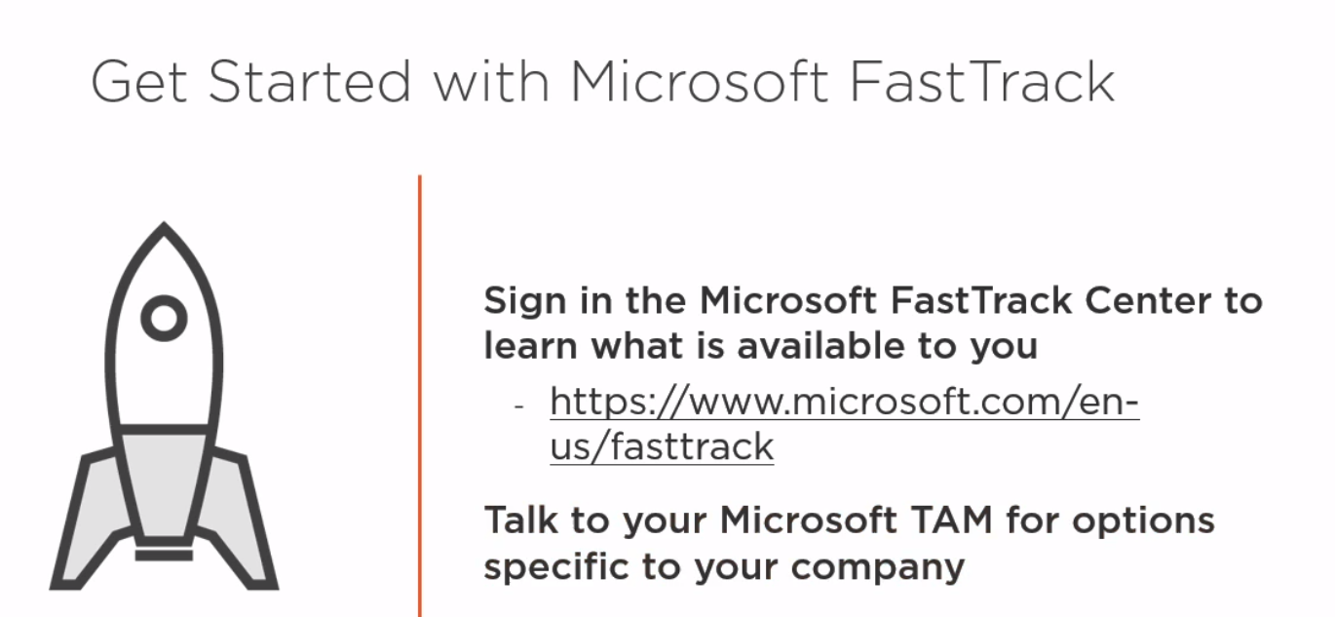

SharePoint Migration Tools

Migrating using PowerShell